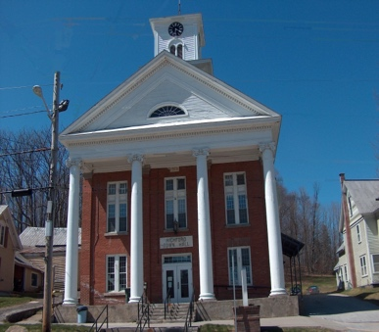
Town of Richford
Selectboard
PO Box 236, 94 Main St.
Richford, VT 05476

Tel. 802-848-7751 Fax 802-848-7752

Special Selectboard Meeting Monday July 24, 2023
2:45 PM

Agenda

- Call Meeting to Order
- Approval of Municipal Tax Rate
- Adjourn

