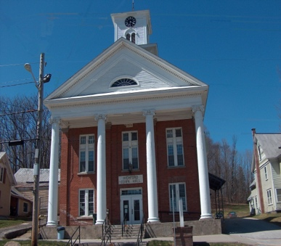
Town of Richford
Selectboard
PO Box 236, 94 Main St.
Richford, VT 05476

Tel. 802-848-7751 Fax 802-848-7752

Selectboard Meeting Monday August 7, 2023
5 PM

This meeting will be held at 5:00 PM!

Agenda

- Call Meeting to Order
- Pledge of Allegiance
- Discussion of Open Meeting Law
- Guests
- Discussion of Post-Office Furnace Quotes
- Renewal of Downtown Village Designation
- Discussion of Rail Trail Extension Project
- Approval of 7/17/23 Selectboard Meeting Minutes & 7/24/23 Special Meeting Minutes
- Update from Town Administrator
- Highway Report
- Buildings Report
- Water and Sewer Report
- Park, Playground, Cemeteries Report
- Other Business
- Adjourn

