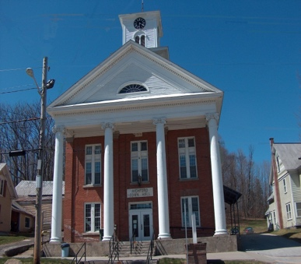
Town of Richford
Selectboard
PO Box 236, 94 Main St.
Richford, VT 05476

Tel. 802-848-7751 Fax 802-848-7752

Selectboard Meeting Monday May 1, 2023
6 PM

Agenda

- Call Meeting to Order
- Pledge of Allegiance
- Guests
- Discussion of Assistant Zoning Administrator
- Discussion of Town Properties
- Discussion of Spring Community Trash Day
- Approval of 4/17/23 Selectboard Meeting Minutes & 4/20/23 Special Selectboard Meeting Minutes
- Update from Town Administrator
- Highway Report
- Buildings Report
- Water and Sewer Report
- Park, Playground, Cemeteries Report
- Other Business
- Adjourn

