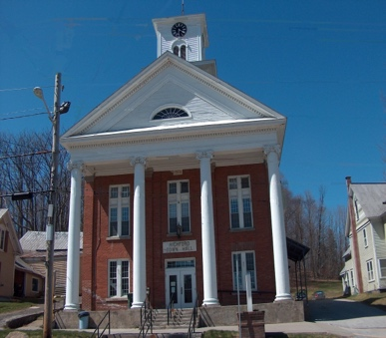
Town of Richford
Selectboard
PO Box 236, 94 Main St.
Richford, VT 05476

Tel. 802-848-7751 Fax 802-848-7752

Selectboard Budget Meeting Monday January 16, 2023
4 PM

Due to the inclement weather, the January 13 budget meeting has been rescheduled to the above date and time.

Agenda

- Call Meeting to Order
- Budget Meeting
- Adjourn

