Spring Bird Walk 101!

Sat. June 4th
7:30 to 10:00 AM
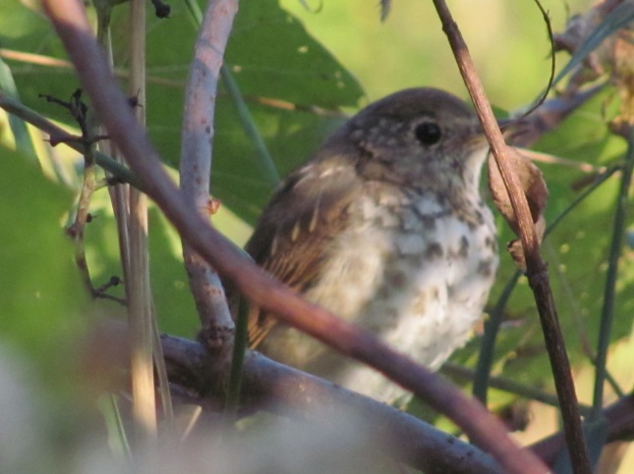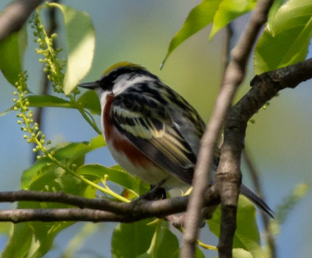

Photo: Rich Kelley
Join us for a spring bird walk along the Missisquoi Valley Rail Trail.
Curious about birds, but overwhelmed by the amount of species you see and songs you hear? Are there just too many little brown birds?
Join us for a walk designed to teach you tools and strategies to observe and learn about birds!
We will provide a few binoculars for novices to use, but bring some if you have them!
(Meet at the Rail Trail where it intersects Hardwood Hill Rd near the Richford Town Garage.)

A FREE event, but donations are welcome to help area birds!
Limited numbers; please register by contacting us at richfordconservation@gmail.com

Sponsored by the Richford, Montgomery, Enosburg, and Bakersfield Conservation Commissions

