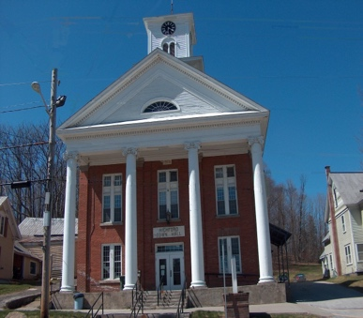
Town of Richford
Selectboard
PO Box 236, 94 Main St.
Richford, VT 05476

Tel. 802-848-7751 Fax 802-848-7752

Selectboard Meeting Monday February 5, 2024
5:00 PM

Agenda

- Call Meeting to Order
- Pledge of Allegiance
- Guest
- Approval of 1/15/24 Meeting Minutes
- Highway Report
- Buildings Report
- Water and Sewer Report
- Town Administrator Update
- Parks, Playground, Cemeteries Report
- Other
- Adjourn

