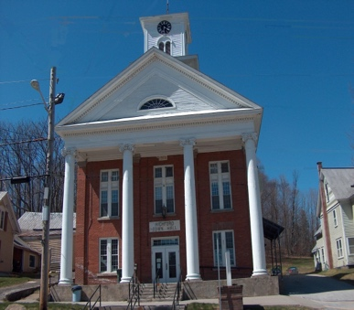
Town of Richford
Selectboard
PO Box 236, 94 Main St.
Richford, VT 05476

Tel. 802-848-7751 Fax 802-848-7752

Selectboard Meeting Monday December 04, 2023
5:00 PM

Agenda

- Call Meeting to Order
- Pledge of Allegiance
- Guest
- Annette Goyne- Richford Conservation Commission
- Catherine Dimitruk, NRPC -Discuss grant opportunity
- Approval of 11/20/23 Meeting Minutes
- Highway Report
- Buildings Report
- Water and Sewer Report
Necessity resolution
- Park, Playground, Cemeteries Report
- Other Business
- Adjourn

