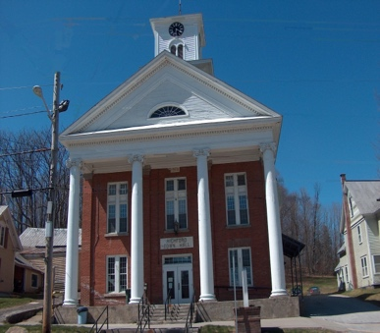
Town of Richford
Selectboard
PO Box 236, 94 Main St.
Richford, VT 05476

Tel. 802-848-7751 Fax 802-848-7752

Selectboard Meeting Monday January 15, 2024
4:00 PM

Agenda

- Call Meeting to Order
- Pledge of Allegiance
- Guest
- Approval of 1/3/24 Meeting Minutes
- Highway Report
- Buildings Report
- Water and Sewer Report
- Town Administrator Update
- Park, Playground, Cemeteries Report
- Other Business (Agreement for Planning Services)
- Adjourn

