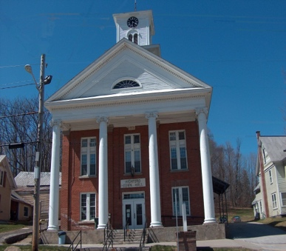
Town of Richford
Selectboard
PO Box 236, 94 Main St.
Richford, VT 05476

Tel. 802-848-7751 Fax 802-848-7752

Selectboard Meeting Monday September 18, 2023
6 PM

Agenda

- Call Meeting to Order
- Pledge of Allegiance
- Guests
- Discussion of Policing with Representative Lisa Hango
- Discussion of Rail Trail Extension Project
- Discussion of Bear Run Road
- Parking Ordinance Review
- Approval of 9/11/23 Meeting Minutes
- Update from Town Administrator
- Highway Report
- Buildings Report
- Water and Sewer Report
- Park, Playground, Cemeteries Report
- Other Business
- Adjourn

