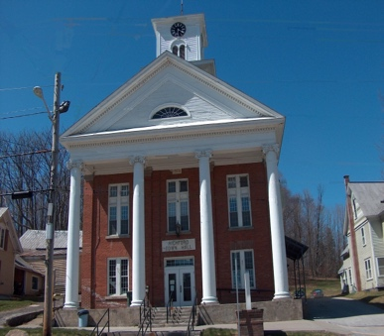
Town of Richford
Selectboard
PO Box 236, 94 Main St.
Richford, VT 05476

Tel. 802-848-7751 Fax 802-848-7752

Special Selectboard Meeting Thursday April 20, 2023
3 PM

Agenda

- Call Meeting to Order
- Approve Vaughn Comeau to Process Tax Sale Properties
- Adjourn

